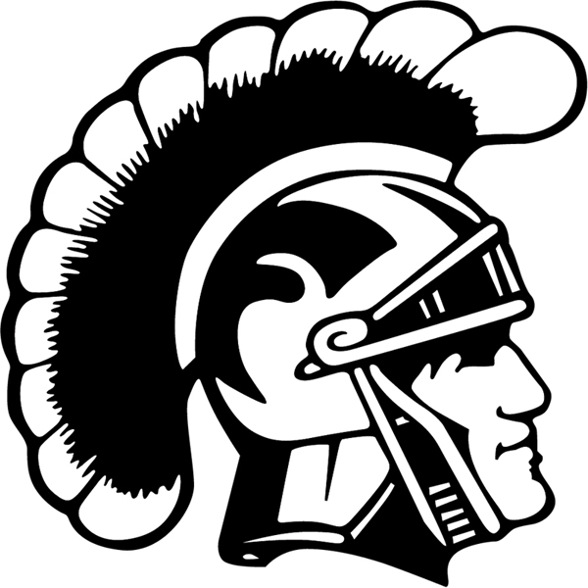

2018-2019 THORNTON ACADEMY
Boys Swimming and Diving Roster

NAME CLASS
Gregorii Bukanov Sophomore
Vladislav Chernov Sophomore
Andrew Cote Senior
Aidan Heiger Freshman
Felix Machacek Senior
Ignacio Morales Senior
Liam Robbins Freshman
Danylo Rybtsock Sophomore
Pavel Sherstyuk Senior

Head Coach: Kathleen Leahy
Assistant Coach: Lynn Steward
Athletic Trainer: Tony Giordano
Mascot: Golden Trojans
School Colors: Maroon and Gold
Headmaster: Rene Menard
Associate Head of School: Marsha Snyder
Athletic Administrator: Gary Stevens

