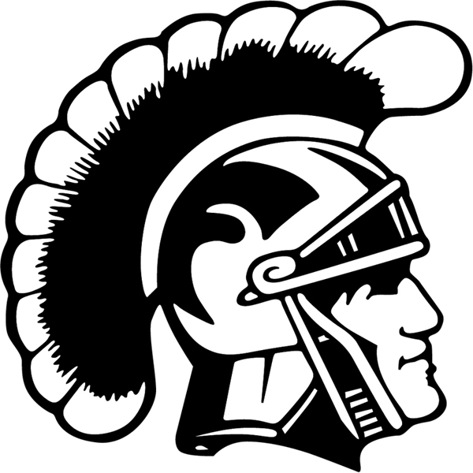

2018-2019 THORNTON ACADEMY
Girls Swimming and Diving Roster

NAME CLASS
Sabrina Alvarez Sophomore
Mariposa Beane Sophomore
Juliana Cardullo Senior
Kaleigh Cote Junior
Grace Courtney Sophomore
Nicole Cyr Junior
Madeline Darigan Freshman
Amalia Doughty Sophomore
Zelie El-Houssani Sarazin Senior
Anna Fomichencko Freshman
Rachel Hill Sophomore
Emily Ireland Senior
Teresa Lodares Junior
Kotryna Malevskyte Junior
Grace Rocheleau Sophomore
Elise Soucy Freshman
Annaliese Spaulding Sophomore
Marie Stepp Freshman
Mary Steward Senior
Grace Tillotson Junior
Ella Toppen Sophomore
Mayu Watanabe Junior
Allison Wormwood Sophomore
Makenna Young Freshman
Winni Zhang Senior

Head Coach: Kathleen Leahy
Assistant Coach: Lynn Steward
Athletic Trainer: Tony Giordano
Mascot: Golden Trojans
School Colors: Maroon and Gold
Headmaster: Rene Menard
Associate Head of School: Marsha Snyder
Athletic Administrator: Gary Stevens

